Law of the Rubber Band
When is a rubber band useful?
What can you do with them?

John C. Maxwell’s states “Growth stops when you lose the tension between where you are and where you could be.” (15 Laws of Growth book, law of growth #10)
Do not settle when selecting a system to implement or a project team to help implement. Settling will lead to disappointment.
Selecting a System | Selecting a Team
Stretch your ideas  Expand beyond the status quo  Select a system that can expand | Choose people that are willing to stretch  Select a cross-functional team  Choose engaged people to create change

Stretching requires growth and can be uncomfortable at times. Openly communicate, help others to stretch and use multiple methods to help others accept the changes. Everyone does not stretch or grow the same or at the same speed. There are several ways to achieve positive results; keep an open mind.
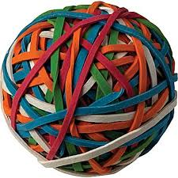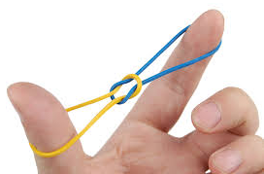
Barriers are created by those unwilling to stretch or create tension and these barriers can become unmovable obstacles. Identify the people that struggle with change and offer additional support without judgment. Take time to hear their concerns and positively present different options.

